**Pre-Workshop Setup for Numerical Problem Solving across the Curriculum with Python and MATLAB Using Interactive Coding Templates**

1 Introduction

2 Access the Workshop Google Drive

3 Open a MATLAB Live Script

3.1 Download .mlx File

3.2 Obtain a MATLAB License

3.3 Option A: Open .mlx in MATLAB Online

3.4 Option B: Open .mlx in a Local MATLAB Client

4 Open a Jupyter Notebook

# 1 Introduction

The workshop will include interactive elements that will require you to open and edit MATLAB Live Scripts (.mlx files) or Jupyter Notebooks (.ipynb files). This document will demonstrate how to access the workshop’s Google Drive folder and how to open and edit .mlx and .ipynb files. If you have any questions regarding these instructions, please contact Austin Johns at anjohns@buffalo.edu.

# 2 Access the Workshop Google Drive

You should have access to the [Numerical Problem Solving across the Curriculum with Python and MATLAB Using Interactive Coding Templates](https://drive.google.com/drive/folders/1mLH08liGxJFxBvP4G-vQUh6_KsuOxKd5?usp=sharing) folder on the ASEE/AIChE Summer School for Engineering Faculty Google Drive. This folder contains all of the MATLAB Live Scripts, Jupyter Notebooks, and PowerPoint presentations used during this workshop.

# 3 Open a MATLAB Live Script

## 3.1 Download .mlx File

To open a MATLAB Live Script from the Google Drive folder, first, download a copy of the .mlx file. This can be done by right-clicking the file and selecting download.

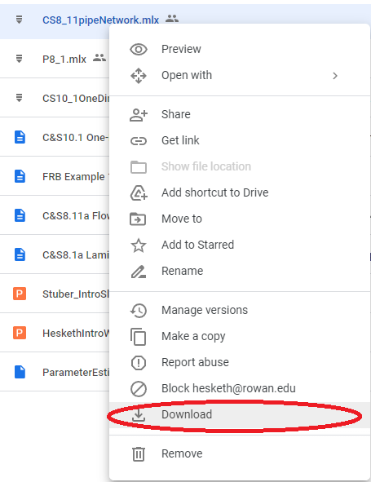

Alternatively, you can double-click the file and select the download icon in the top-right of the screen. Double-clicking a .mlx file will show you the hidden contents of the file, but the downloaded file will run properly on a local MATLAB client or on MATLAB Online.

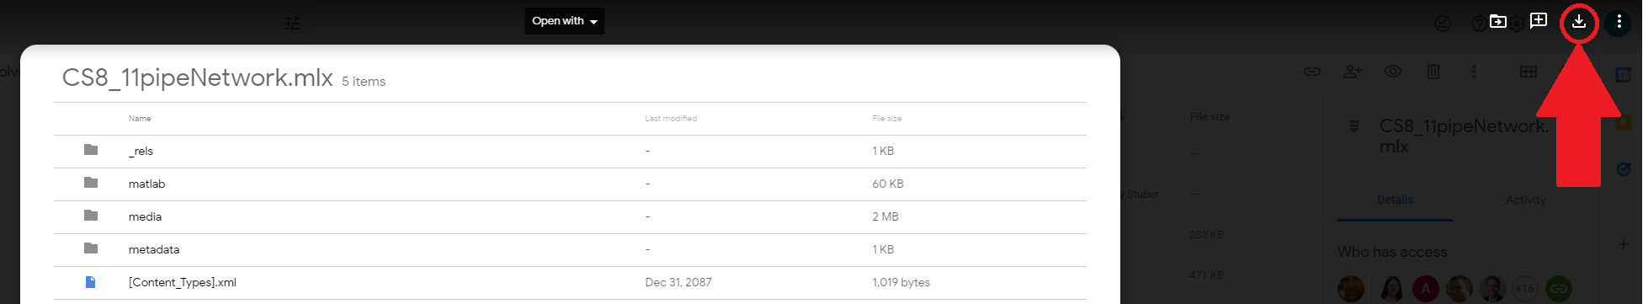

Once you have a local copy of the desired .mlx file, you can either open it with a local MATLAB client or upload it to [MATLAB Drive](https://drive.matlab.com/files/) to open it in MATLAB Online.

## 3.2 Obtain a MATLAB License

The local MATLAB client and MATLAB Online both require access to a MATLAB license, typically provided through an organizational account. For example, the State University of New York at Buffalo provides MATLAB licenses to students, faculty, and staff via [UBIT](https://www.buffalo.edu/ubit/service-guides/software/by-title/matlab.html). The process of acquiring MATLAB licenses and their availability varies by institution. If you intend to focus on MATLAB Live Scripts during this workshop, please investigate the specifics of your institution and contact IT services if you require assistance. If you are unable to secure a MATLAB license, the workshop will also be covering Jupyter Notebooks as a free, open-source alternative to MATLAB Live Scripts.

## 3.3 Option A: Open .mlx in MATLAB Online

Go to your [MATLAB Drive](https://drive.matlab.com/files/) (drive.matlab.com). You will need a MathWorks account associated with your MATLAB license to access MATLAB Drive. Upload the .mlx file you downloaded from the Summer School folder to your MATLAB Drive.

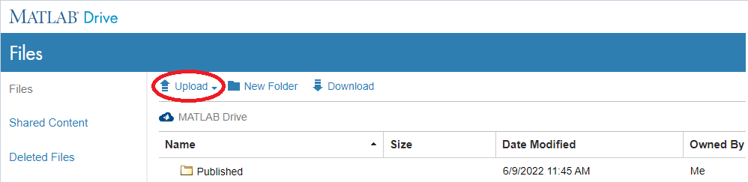

Double-click the uploaded .mlx file and select the option to open the file in MATLAB Online.

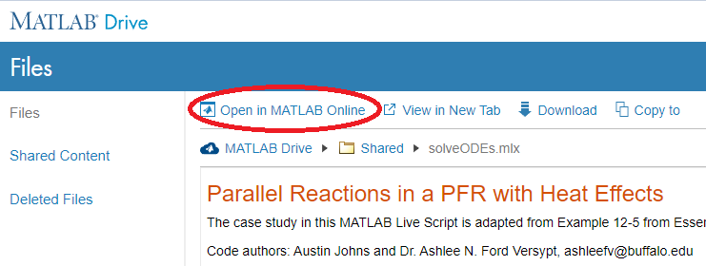

## 3.4 Option B: Open .mlx in a Local MATLAB Client

Download and install [MATLAB](https://www.mathworks.com/downloads) to your own computer (if choosing this option, make sure to bring this computer to the Summer School and determine if your license requires internet access or VPN use to access off campus). Login using the MathWorks account associated with your MATLAB license. Double-click on the downloaded .mlx file to open the file in MATLAB. Alternatively, open MATLAB and use the integrated file explorer to open the downloaded .mlx file.

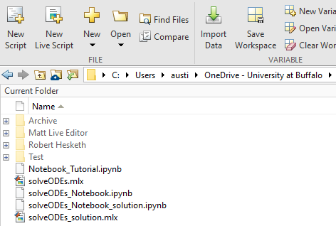

# 4 Open a Jupyter Notebook

To open a Jupyter Notebook from the Google Drive folder, you will need a Google account. If you do not have a Google account, you can create one by following these linked [instructions](https://support.google.com/accounts/answer/27441?hl=en). Once you are logged in to your Google account, you can double-click on a .ipynb file in the Google Drive folder and the notebook will open in Google Colab. These files are saved as read-only and will display "cannot save changes" on the right side of the top toolbar.

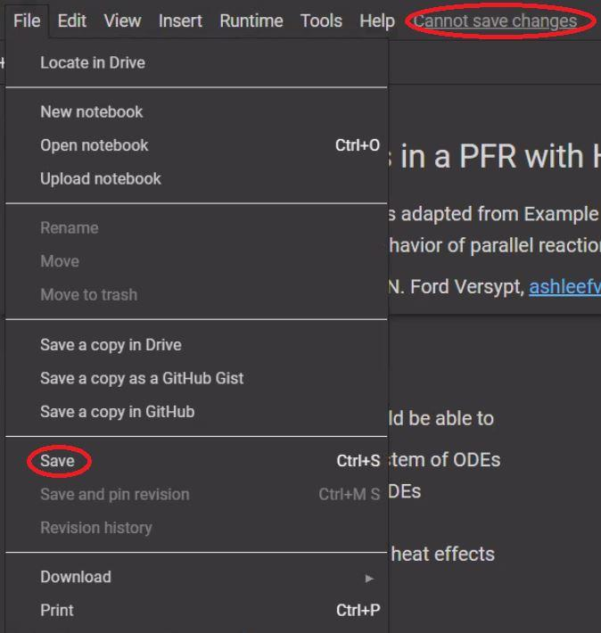

To save an editable copy of any of the provided notebooks, select the "Save a copy in Drive" option from the "File" tab on the top toolbar. Alternatively, select the "Save" option highlighted in the previous image. This will cause the following popup to appear and prompt you to "Save a copy in Drive." The download option also allows you to download a local copy of the .ipynb file which can be uploaded and edited in Google Colab using the "Upload notebook" option.

